**Assignment 07:**

1. **Compute Amount payable given principal amount, rate of simple interest, time in years.**

**Code:**

#!/bin/bash

echo "Enter principal amount: "

read pa

echo "Enter time(in years): "

read t

echo "Rate of interest: "

read r

i=`expr $pa \* $t \* $r / 100`

echo "Simple Interest is: $i"

**Output:**

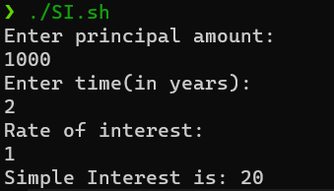

1. **Search for a file in a directory structure.**

**Code:**

#!/bin/bash

echo "Enter the filename"

read file

if test -e $file

then

echo "File exists"

else

echo "File does not exist"

fi

**Output:**

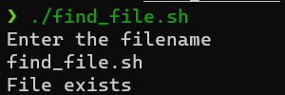

1. **Create an array of strings for months of a year. Enter the number of month and display the name of month.**

**Code:**

#!/bin/bash

arr=(No_month January February March April May June July August September

October November December)

echo "Enter the number of month: "

read m

echo "The month is: "${arr[$m]}

**Output:**

